Week 3 - Flowcharts & Conditionals

Flowcharts

A flow chart is a diagram that shows a process involving decisions. Depending on the decisions, the process might go in different directions.

Here’s an example of a flowchart describing how to make a bath (at least one way to do it). Note that we are using 3 shapes, each of which has a particular role in the flow chart. Some flowcharts use other shapes to mean other things, but these will be enough for us.

Start
Increase Hot Water
Increase Cold Water
Too Hot?
Too Cold?
Full Enough?
Start
Turn off water
Yes
No
No
No
Yes
Yes
Start/End
Action
Decision
Flowchart shapes

Conditionals in Scratch

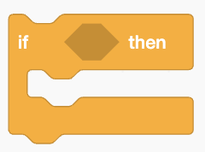 | Checks the condition in the hexagon and executes the code inside the block if TRUE. If the condition is FALSE, the code inside the if block is not executed.
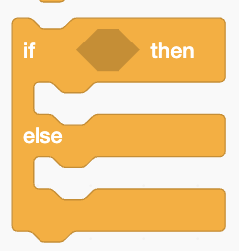 | Like the simpler if block, but includes the option to execute the code in the ‘else’ block if the condition is FALSE.
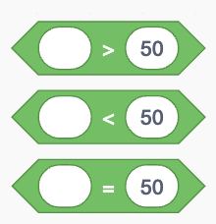 | These blocks test conditions and resolve to TRUE or FALSE. The equals block can be used with text too. Note that their shape fits into the “holes” of the if blocks.
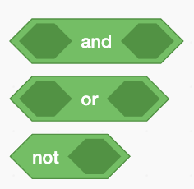 | These blocks are for making evaluating more complex conditions. The “and” block is true if and only if BOTH of the conditions it contains are true. The “or” block is true if EITHER of the conditions are true. The “not” block is true if the condition is contains is false.

Input and Variables

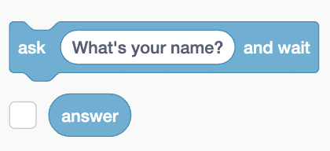 | Makes the sprite ask a question and display a text box for the user to answer. The user’s answer is stored in the variable “answer”

Examples
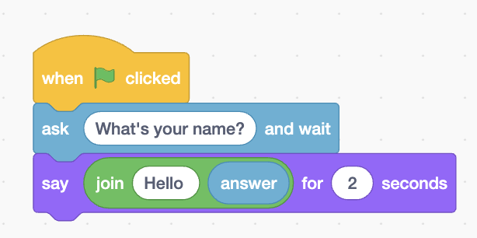 | Shows how to ask for user input and use the answer elsewhere in the program. Also shows how to use the “join” block to put text together.
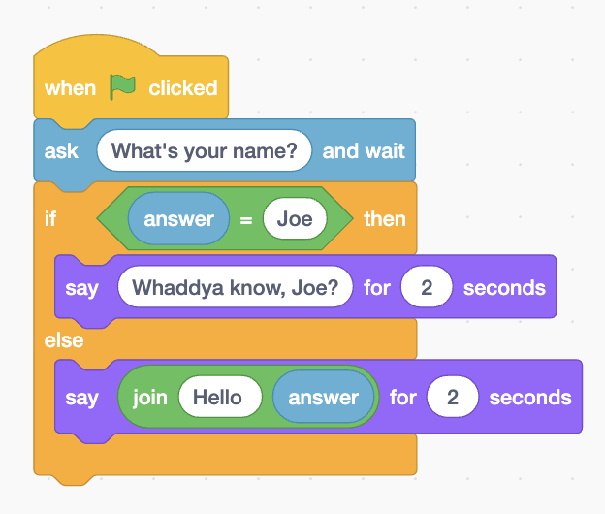 | Shows how to use an if-else block to reply differently based on the user’s answer. Note also that the “equals” block can be used with text as well as numbers.
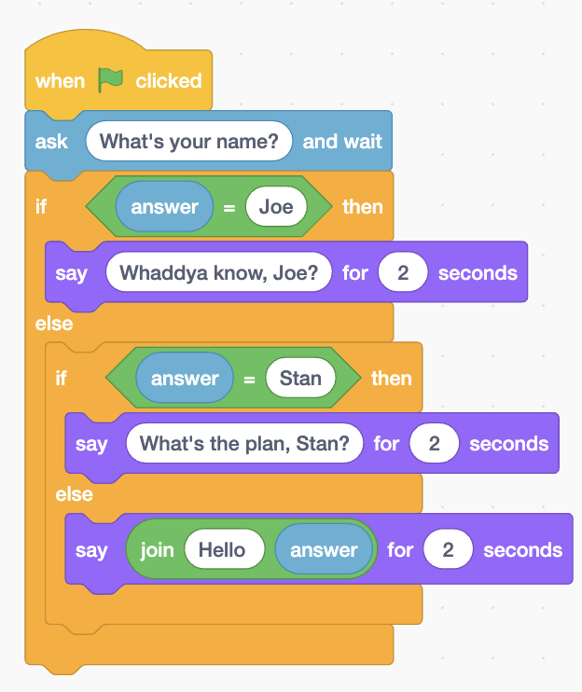 | You can “nest” if (or if-else) blocks inside other ones. This program asks the user’s name and has special responses if their name is “Joe” or “Stan.”
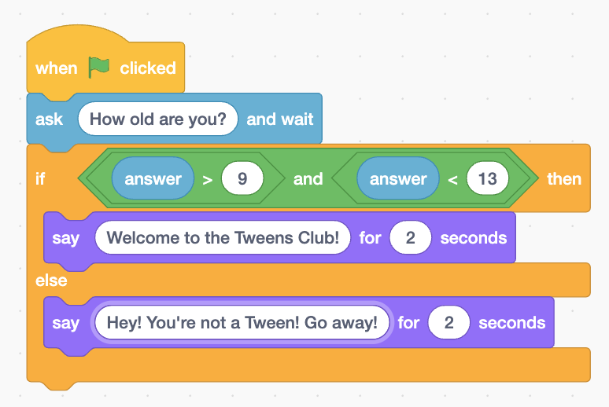 | This shows using an “and” block to test two conditions at once to see if they’re both true.

Worksheet

Challenge #1: Flowchart

Complete the following flowchart to determine if an animal is a fox, a cow, a human, or a pigeon. Assume those are the only four animals it can be, and here are the general characteristics of each animal.

Animal | # of legs | Weight range
Fox | 4 | 5-15 lbs
Cow | 4 | 300-700 lbs
Pigeon | 2 | 1-3 lbs
Human | 2 | 100-300 lbs

Start
Get animal
It’s a fox!
It’s a cow!
It’s a human!
It’s a pigeon!

Challenge #2: Scratch Program
Write a program to have a sprite that asks what the current temperature is and suggests an appropriate activity.

Here is what the sprite should suggest based on different temperatures:
Min Temp (> or =) | Max Temp (<) | Activity
10 | 30 | Go skiing!
30 | 50 | Play golf! But wear a sweater!
50 | 80 | Play soccer!
80 | 99 | Go swimming! Don’t forget your sunscreen!
Anything else |  | Stay inside! Are you crazy?

Requirements (checklist)
- When flag is clicked, sprite asks for the temperature.
- Sprite gives a suggestion if the temp is between 10 and 30
- Sprite gives a suggestion if the temp is between 30 and 50
- Sprite gives a suggestion if the temp is between 50 and 80
- Sprite gives a suggestion if the temp is between 80 and 99
- Sprite gives a suggestion if the temp is below 10 or above 99
- Sprite’s costume and background change to match the activity suggested (for all suggestions)

Challenge #3: Rock Shirt Wand
BONUS! If you have time left!

Write a program to play Rock Shirt Wand (a version of Rock Paper Scissors that uses costumes that actually exist in Scratch).

- A sprite asks the user whether they want to pick rock, shirt, or wand.
- The sprite’s costume should change to be whatever was picked.
- A second sprite should rapidly cycle through all available costumes (rock, shirt, wand) before stopping on one of them, which should be randomly selected.
- Depending on what each player picked (the human player and the random-selection player), the “other” player (the random one) should say either “I win!”, “You win!”, or “It’s a tie!” I think you all know this, but rock beats wand (scissors), wand beats shirt (paper), and shirt beats rock.

